R/L/DGM/CN/1458

Recovery Section,

CTO Building,

Ground Floor,

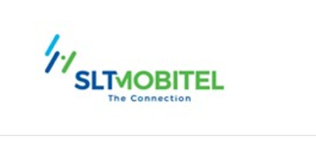 Sri Lanka Telecom PLC

Lotus Rd,

Colombo 01

31 07 2023.

**Without Prejudice**

Dear Sir/Madam,

**011 3654477 Default of Payment Telephone Bills**

This refers to your letter dated 21 07 2023 on the above. Your matter has been referred to Deputy General Manager/Recoveries to take necessary action on payments and resolve any disputes connected thereto.

We hereby inform you to contact the Customer Care Officer -Recoveries Sri Lanka Telecom on telephone No. 0113-434887 discuss above matter for a settlement with the referred Account Number.

Yours Faithfully,

Customer Care Officer, Recovery Section-Legal

Sri Lanka Telecom.